Solution Approach:
There are a few steps, how to create an application for statistical analysis of CSV files - with the Pandas. Here's a structured approach:
1. Requirements and scope definition:
Functionalities:
- CSV file upload and parsing.
- Simple Summary Statistics (Mean, median, mode etc.)
- Create Multiple Plots (Histograms, Scatter plots, Box Plot and so on.....)
- Query insights for data, using natural language interface.
2. Set Up Development Environment:
- Programming language:
Choose python for data analysis and machine learning.
- Libraries:
Pandas for data manipulation.
Matplotlib , seaborn, and plotly for data visualization.
- Environment:
Install requires libraries.
3. CSV file handling:
Csv parsing:
Use pandas to read and parse CSV file
import pandas as pd
data = pd.read_csv('ice.csv')

4. Statistical Analysis:
Mean:
print("mean at row_wise")
df.mean(axis=1)

Mode:
print(“mode”)
df.mode()

Median:
print("median at row_wise")
df.median(axis=1)

Coefficient correlation:
print("Coefficient Corelation")
df.corr()
sns.regplot(x=df.Flavor_Rating,y=df.Texture_Rating)
plt.show()

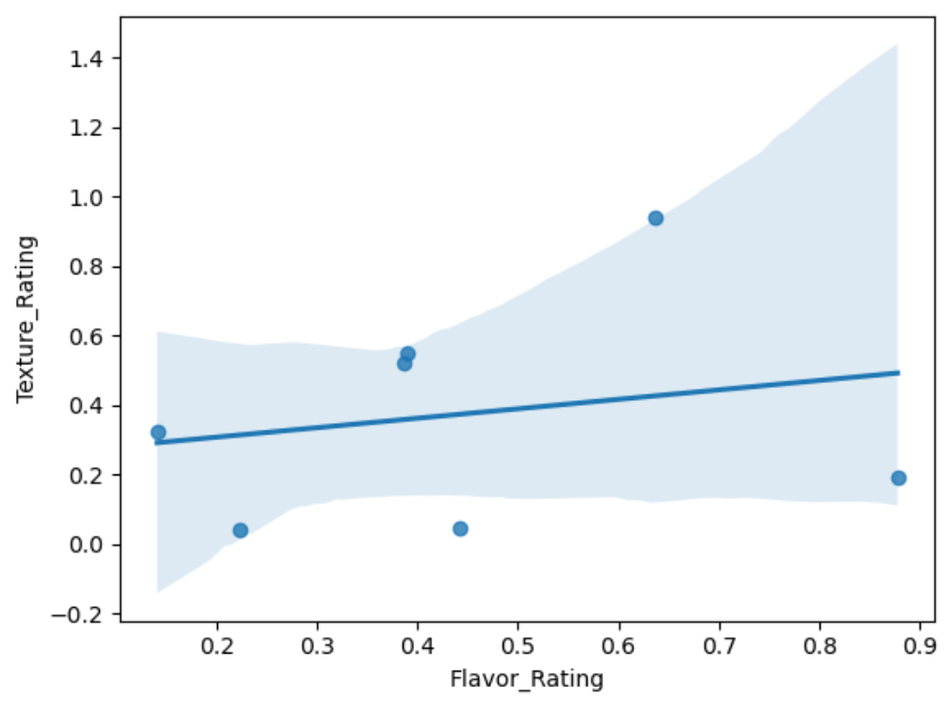
5. Plot Generation:
import matplotlib.pyplot as plt
import seaborn as sns

Histograms:
df.plot.hist(bins=20)

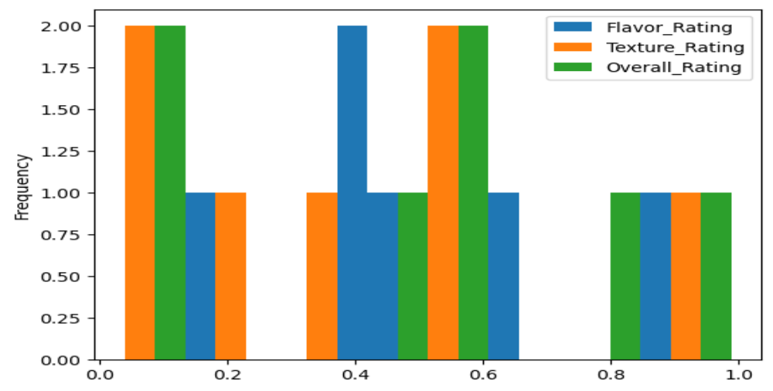
Scatter plots:
df.plot.scatter(x = 'Texture_Rating', y = 'Overall_Rating', s = 500, c ='yellow')

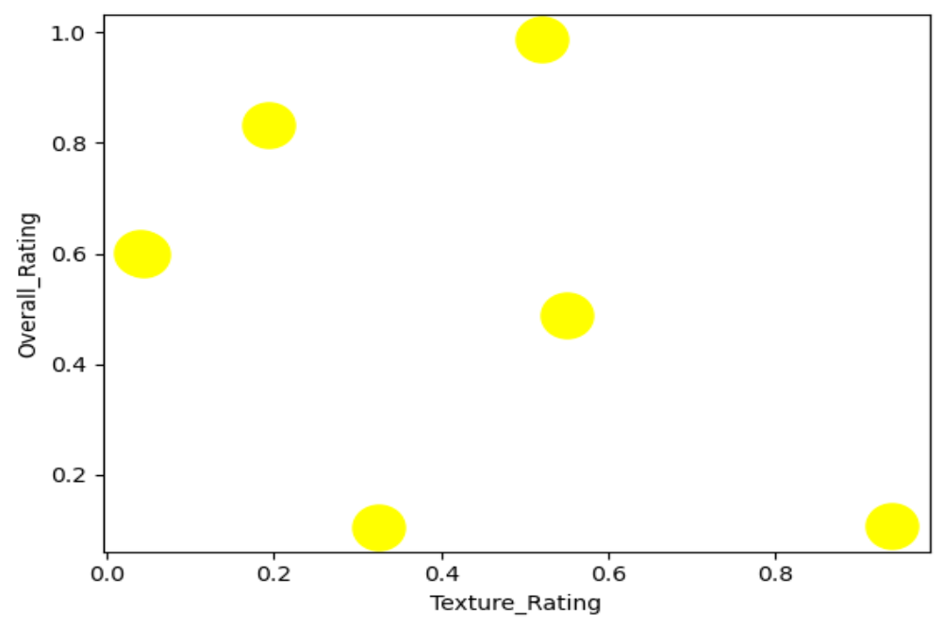

Line plots:
df.plot(kind = 'line', title = 'Ice Cream Ratings', xlabel = 'Daily Ratings',ylabel = 'Scores')

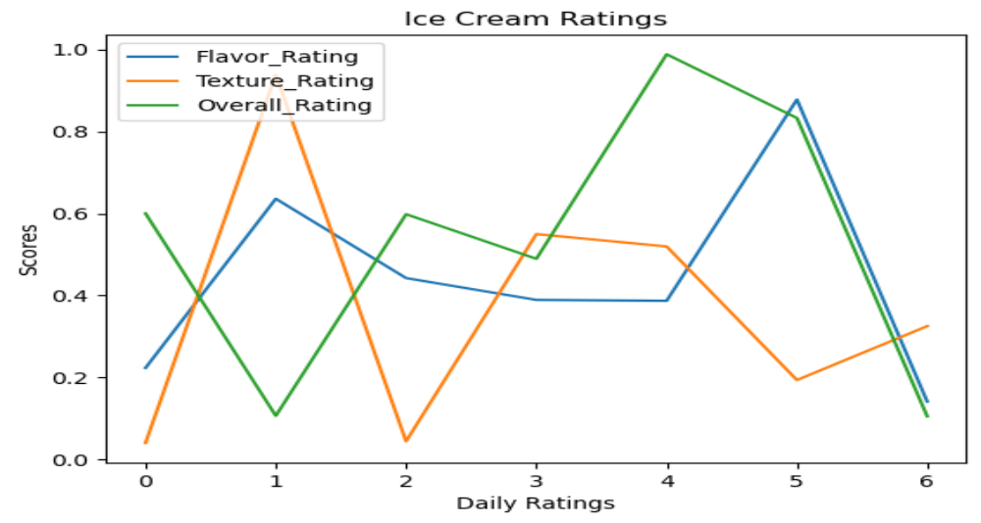
Pie chart:
df.plot.pie(y='Flavor_Rating',figsize=(10,10))

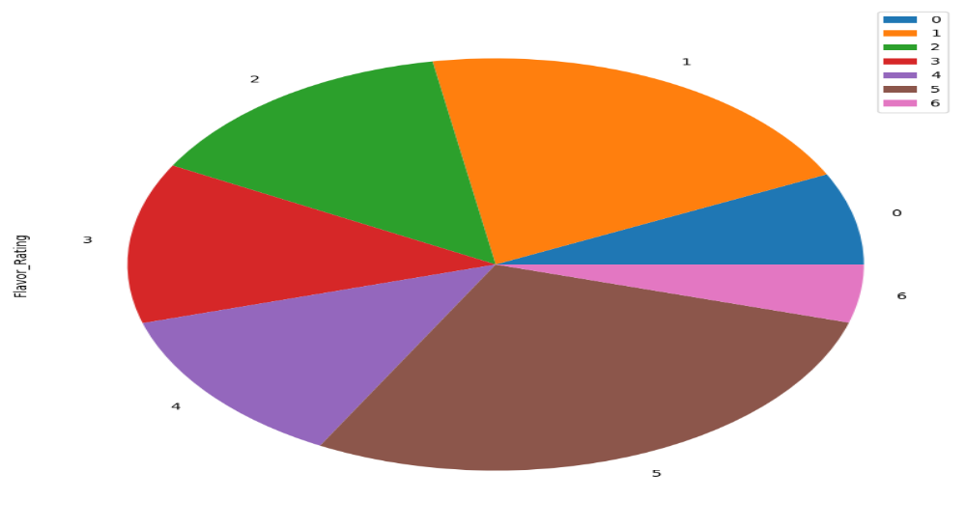
Area plot:
df.plot.area(figsize = (10,5))

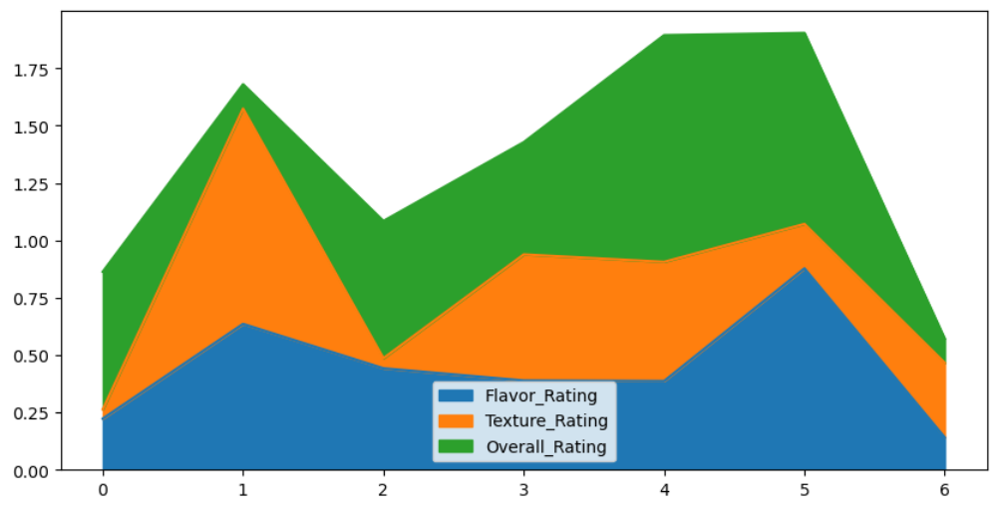

6. Maintenance:
- Updates and maintenance time to time.
- Gather user feedback for continuous improvement.

